King Fahd University of Petroleum and Minerals
Information and Computer Science Department

ICS 103: Computer Programming in C
Spring Semester 2006-2007 (Term-062)

Final Exam

Time:120 minutes Saturday June 9, 2007

Name:
ID#:

PLEASE CIRCLE YOUR SECTION BELOW:

Section | 1 | 2 | 3 | 4 | 5 | 6 | 7
Time | SM-8-9 | SM 9-10 | SM 11-12 | UT 9-10 | UT 11:12 | UT 8-9 | UT 10-11

Note:

- Copying or Discussion will result in zero grade for all the students involved.
- Attempt all questions.

Question # | Maximum Marks | Obtained Marks
1-1,1-2 | 8+6 = 14
1-3,1-4 | 2x8=16
1-5,1-6 | 9+6=15
2 | 10
3 | 15
4 | 15
5 | 15
Total | 100

Good Luck

Question 1: (45 points)

Find the out of the following programs.
Program | Output
#include <stdio.h> // 8 points  #include <string.h>  #include <ctype.h>  int main() {  char x[]="13.6";  int value=0,j=1,i;  for(i=strlen(x)-1;i>=0;i--) {  if(isdigit(x[i])){  value=value+(x[i]-'0')*j;  j=j++;  }  printf("%d\n",value);  }  return 0;  } | 6  6  12  15
#include <stdio.h> // 6 points  void fun (char s1[], char s2[]){  int i;  char t;  for (i=0; s1[i]!='\0'&&s2[i]!='\0'; i++) {  t = s1[i];  s1[i] = s2[i];  s2[i] = t;  }}  int main () {  char m[]="abcd123";  char n[]="tnf6";  fun(n,m);  puts(m);  puts(n);  return 0;  } | tnf6123  abcd
#include <stdio.h> // 8 points  #define N 5  int f(int z) {  return(z*z);  }  void main() {  int a[N];  int b=1,k;  for (k=0; b<N ; ++k) {  b += k;  a[k] = f(b);  }  for (b=0;b<k;++b)  printf("%d ",a[b]);  } | 1 4 16 49
#include <stdio.h> // 8 points  void fun(int *a, int *b) {  if(*a%2)  *b=*a+1;  else if(*a%3)  *b=*a-1;  else  *b=*a;  }  int main() {  int a[][4]={2,5,8,13,36,19,24};  int b[2][4],i,j;  for(i=0;i<2;i++) {  for(j=0;j<4;j++) {  fun(&a[i][j],&b[i][j]);  printf("%d\t",b[i][j]);  }  printf("\n");  }  return 0; } | 1 6 7 14  36 20 24 0
#include <stdio.h> // 9 points  int main() {  int a[3][3],i,j;  printf("Enter 9 values >");  for(i=2;i>=0;i--) {  for (j=i;j>=0;j--) {  if(i==j)  scanf("%d",&a[i][j]);  else  scanf("%d%d",&a[i][j],&a[j][i]);  }  }  for(i=0;i<3;i++){  for(j=0;j<3;j++)  printf("%d\t",a[i][j]);  printf("\n");  }  return 0;  }  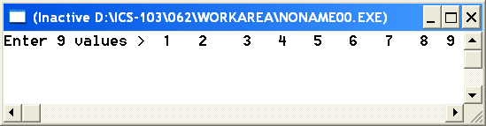 | 9 8 5  7 6 3  4 2 1
#include <stdio.h> // 6 points  int main() {  int a=7,b=2,c;  int *p1,*p2;  p1=&a;  p2=&b;  *p2=*p1-2;  *p1=b+3;  c=a+b;  printf("a=%d, b=%d, c=%d",a,b,c);  return 0;  } | a=8, b=5, c=13

Question 2 : (10 points)
Write a function pattern that receives a parameter n and prints the pattern shown in the table on the screen. The table shows 4 calls to pattern with different values of n. For each value of n, the second row shows what will be printed on the screen. Don’t write the main function.
Hint: Use nested loops.

pattern (1) | pattern (2) | pattern(3) | pattern(5)
D | DU  LD | DUU  LDU  LLD | DUUUU  LDUUU  LLDUU  LLLDU  LLLLD

#include <stdio.h>
void fun (int n) {
int i,j;
for (i=0;i<n;i++) {
for (j=0;j<n;j++) {
if(i==j)
printf("%c",'D');
else if(i>j)
printf("%c",'L');
else
printf("%c",'U');
}
printf("\n");
}
}

Question 3: (15 points)
Write a program that reads the values of a matrix of 3 rows by 4 columns row by row. After storing the values in the array your program should find the location of the maximum value i.e. its row index and its column index and print the information as shown below.

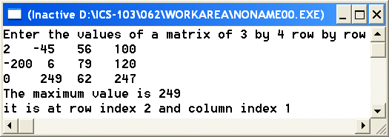

#include <stdio.h>
int main() {
int x[3][4],i,j,imax,jmax;
printf("Enter the values of a matrix of 3 by 4 row by row\n");
for(i=0;i<3;i++){
for(j=0;j<4;j++)
scanf("%d",&x[i][j]);
}
imax=0;jmax=0;
for(i=0;i<3;i++) {
for(j=0;j<4;j++) {
if(x[i][j]>x[imax][jmax]) {
imax=i;
jmax=j;
}
}
}
printf("The maximumvalue is %d\n",x[imax][jmax]);
printf("it is at row %d and column %d",imax,jmax);
return 0;
}

Question 4: (15 points)
Write a program that declares a two dimensional array of integer values of 20 by 20. Then it will read from the user the size of a square matrix followed by the values of this matrix row by row. Your program should test for the symmetry of the entered matrix and print the right message as shown below for the 2 samples runs.
A square matrix b is symmetric if b(i,j)equals b(j,i) for all i and j. In the second run, the matrix is not symmetric because 3(first row, third column) not equal to 4 (third row, first column)

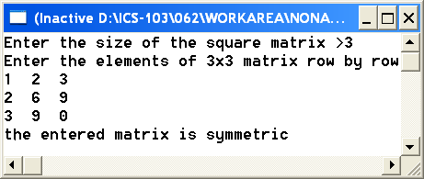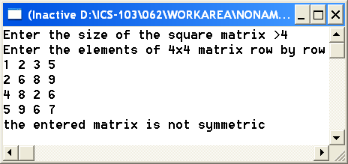
#include <stdio.h>
int main () {
int x[20][20],i,j,dim;
int sym=1;
printf("Enter the size of the square matrix >");
scanf("%d",&dim);
printf("Enter the elements of %dx%d matrxi row by row\n",dim,dim);
for(i=0;i<dim;i++){
for(j=0;j<dim;j++)
scanf("%d",&x[i][j]);
}
for(i=0;i<dim&&sym;i++) {
for(j=0;j<i&&sym;j++) {
if(x[i][j]!=x[j][i])
sym=0;
}
}
if(sym)
printf("the entered matrix is symmetric");
else
printf("the entered matrix is not symmetric");
return 0;
}
Question 5: (15 points)
Write a function countdiglet that receives a string containing letters, digits, and other symbols. The function will return two values (number of digits and number of letters) using output parameters.
Write a main function where you read a string from the user, call the function countdiglet, and print the results as shown below.

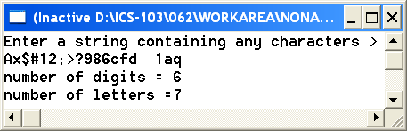

#include <stdio.h>
#include <string.h>
#include <ctype.h>
void countdiglet(char text[], int* digits , int* letters) {
int i;
*digits=0;
*letters=0;
for(i=0;i<strlen(text);i++) {
if(isdigit(text[i]))
*digits=*digits+1;
else if (isalpha(text[i]))
*letters=*letters+1;
}
}

int main() {
char text[80];
int digits,letters;
printf("Enter a string containing any characters >\n");
gets(text);
countdiglet(text,&digits,&letters);
printf("number of digits = %d\n",digits);
printf("number of letters =%d",letters);
return 0;
}

